

PROJECT : **PHONE BOOK APPLICATION**

NAME : **SP.DRAVID PRABAKARAN**

REG NO : **RA2111002010121**

DEPARTMENT : **MECHANICAL ENGINEERING**

SUBMITTED TO :**DR. R. RAJKUMAR,**

**DSBS,**

**SCHOOL OF COMPUTING,**

**SRMIST.**

**ABSTRACT:**

The phonebook application works specifically for tracking people. The Phonebook application contains a set of basic functions for adding, searching, updating, and deleting new contacts. This mini-C phonebook design allows you to perform simple tasks in your phonebook, such as mobile phones. You can add text to the phonebook, find, edit, search, and delete. The concept of file management and data structure is often used in almost all functions in this project. It uses functions, file management, and data structure. This application provides information on adding, viewing, modifying, receiving, and deleting data from/to files. Adding new entries, browsing them, editing and updating, searching for saved contacts, and deleting contacts in the phonebook is one of the most important services that become the main menu in the phonebook application. When you add anything to your phone book, you will be asked for personal information such as name, gender, first name, phone number, nationality, email address, and address. You can then edit, view, search, and delete this text.

**AIM OF THE PROJECT**:

Create a “Contact Phonebook” framework using C programming. This software is very useful nowadays to store full information under a single contact number. The software also has options for removing and changing the contact number entered.

**ADVANTAGES AND DISADVANTAGES:**

1. It is simple for the user to store complete information (e.g. e-mail ID, address) about his or her contact.
2. It’s simple for the user to simply check his appropriate contact number by entering the contact name.
3. Often it’s hard to store more contacts (i.e over 150).
4. It is also difficult to store contacts with two or more contact numbers.

**CODE:**

#include<stdio.h>

#include<conio.h>

#include<stdio.h>

#include<string.h>

#include<stdlib.h>

#define FILENAME "PHONEBOOK.PHN"

struct PhoneBook**{**

char name**[**100**];**

char address**[**200**];**

int phoneNo**;**

char email**[**100**];**

**};** void mainMenu**();**

void addContact**(**FILE **\***fp**);**

void readContacts**(**FILE **\*);**

void deleteContact**(**FILE **\*);**

void modifyContact**(**FILE **\*);**

PhoneBook basicDetails**(**char**[]);**

void searchContact**(**FILE **\*);**

int checkForMatch**(**char**[],**char**[]);**

void menuDesign**(**char**[]);**

void showMessage**(**char**[]);**

void pressForMainMenu**();**

void fileOpen**(**FILE **\*);**

void fileClose**(**FILE **\*);**

main **() {**

system**(**"cls"**);**

mainMenu**();**

**}**

void mainMenu**(){**

printf**(**"\n\n\n\n\n\t\tLOADING . PLEASE WAIT...."**);**

FILE **\***fp**;**

fp**=**fopen**(**FILENAME**,**"rb+"**);**

**if(**fp**==NULL) {**

fp**=**fopen**(**FILENAME**,**"wb+"**);**

**if(**fp**==NULL) {**

printf**(**"CANNOT OPEN THE FILE"**);** **}**

**}**

system**(**"cls"**);**

int choise**;**

char ch**;** int result**;** printf**(**"\n\n"**);** menuDesign**(**"PHONEBOOK MANAGEMENSYSTEM"**);** printf**(**"\n\t\t1. ADD NEW CONTACT"**);**

printf**(**"\n\t\t2. VIEW ALL CONTACTS"**);**

printf**(**"\n\t\t3. SEARCH CONTACTS"**);**

printf**(**"\n\t\t4. MODIFY CONTACTS"**);**

printf**(**"\n\t\t5. DELETE CONTACT"**);**

printf**(**"\n\t\t6. EXIT"**);**

printf**(**"\n\n\n\t\t ENTER YOUR CHOISE : "**);**

fflush**(**stdin**);**

ch**=**getche**();**

system**(**"cls"**);**

**switch(**ch**){**

**case** '1' **:**

addContact**(**fp**);**

**break;**

**case** '2'**:**

readContacts**(**fp**);**

**break;**

**case** '3'**:**

searchContact**(**fp**);** **break;**

**case** '4'**:**

modifyContact**(**fp**);**

**break;**

**case** '5'**:**

deleteContact**(**fp**);**

**break;**

**case** '6'**:**

exit**(**0**);**

**break;** **default:**

system**(**"cls"**);**

showMessage**(**"ERROR !! PRESS 1-6 ONLY"**);** pressForMainMenu**();**

getch**();** **}**

**}**

void searchContact**(**FILE **\***fp**){** menuDesign**(**"SEARCH CONTACT"**);**

PhoneBook ph**;** int result**;**

int count**=**0**;**

char item**[**50**];**

printf**(**"\n\t\tEnter Some text to be Searched : "**);**

scanf**(**"%s"**,&**item**);**

**while(**fread**(&**ph**,sizeof(**ph**),**1**,**fp**)==**1**){**

result**=**checkForMatch**(**ph**.**name**,**item**);**

**if(**result**==**1**){** count**++;**

printf**(**"\n \t\t Name : %s \n\t\t Address : %s \n\t\t E-Mail :%s\n\t\t Phone No %d \n\n"**,**ph**.**name**,**ph**.**address**,**ph**.**email**,**ph**.**phoneNo**);** **}**

**}**

fclose**(**fp**);**

**if(**count**==**0**)**

printf**(**"\n\t\tNothing found for Name : %s"**,**item**);**

**else**

printf**(**"\n\t\tTotal %d no of Contact(s) found for : %s"**,**count**,**item**);**

pressForMainMenu**();** **}**

int checkForMatch**(**char a**[],**char b**[])** **{**

int i**,**k**;**

char **\***p**,**temp**[**strlen**(**b**)];**

**if(**strlen**(**a**)>=**strlen**(**b**)){**

**for(**i**=**0**;**i**<=(**strlen**(**a**)-**strlen**(**b**));**i**++)** **{**

p**=&**a**[**i**];**

k**=**0**;**

**while(**k**!=**strlen**(**b**))** **{**

temp**[**k**]=*(**p**+**k**);** k**++;** **}**

temp**[**k**]=**'\0'**;**

printf("\nOriginal : %s ~~~~~ Temp : %s\n",b,temp);

**if(**strcmp**(**strupr**(**temp**),**strupr**(**b**))==**0**)** **{**

**return** 1**;** **}**

**}**

**}** **return** 0**;** **}**

PhoneBook basicDetails**(**char level**[**200**]){**

PhoneBook ph**;**

menuDesign**(**level**);**

printf**(**"\n\t\tEnter Name : "**);**

scanf**(**"%s"**,&**ph**.**name**);**

printf**(**"\n\t\tEnter Address : "**);**

scanf**(**"%s"**,&**ph**.**address**);**

printf**(**"\n\t\tEnter E-Mail : "**);**

scanf**(**"%s"**,&**ph**.**email**);**

printf**(**"\n\t\tEnter phoneNo : "**);**

scanf**(**"%d"**,&**ph**.**phoneNo**);**

**return** ph**;** **}**

void addContact**(**FILE **\***fp**){**

char another**=**'Y'**;**

PhoneBook ph**;**

**while((**another**==**'Y'**)||(**another**==**'y'**)){** system**(**"cls"**);**

ph**=**basicDetails**(**"ADD NEW CONTACT"**);**

fseek**(**fp**,**0**,**SEEK_END**);**

fwrite**(&**ph**,sizeof(**ph**),**1**,**fp**);**

printf**(**"\n\n\t\t-------------------------------------------------"**);**

printf**(**"\n\t\tAdded Successfully"**);**

printf**(**"\n\n\t\t-------------------------------------------------"**);**

printf**(**"\n\n\t\tWant to add Another Contact ( Y / Any Key ) : "**);**

fflush**(**stdin**);**

another**=**getche**();** **}**

**if(**another**!=**'Y'**||(**another**!=**'y'**)){**

fclose**(**fp**);**

system**(**"cls"**);**

mainMenu**();** **}**

**}** void readContacts**(**FILE **\***fp**){**

int count**=**0**;** char keyPress**;** rewind**(**fp**);** PhoneBook ph**;** menuDesign**(**"ALL CONTACTS"**);** **while(**fread**(&**ph**,sizeof(**ph**),**1**,**fp**)==**1**){**

count**++;**

printf**(**"\n \t\t Name : %s \n\t\t Address : %s \n\t\t E-Mail :%s\n\t\t Phone No : %d \n\n"**,**ph**.**name**,**ph**.**address**,**ph**.**email**,**ph**.**phoneNo**);**

**}**

**if(**count**==**0**){**

showMessage**(**"Nothing To Display ..... "**);** **}**

fclose**(**fp**);**

pressForMainMenu**();** **}**

void deleteContact**(**FILE **\***fp**){**

system**(**"cls"**);**

menuDesign**(**"DELETE CONTACT"**);**

PhoneBook ph**;** FILE **\***temp**;** int count**=**0**;** char name**[**50**];** temp**=**fopen**(**"TEMP.DAT"**,**"wb+"**);** printf**(**"\n\t\tEnter Contant Name to Delete : "**);**

scanf**(**"%s"**,&**name**);**

rewind**(**fp**);**

**while(**fread**(&**ph**,sizeof(**ph**),**1**,**fp**)==**1**){**

**if(**strcmp**(**strupr**(**ph**.**name**),**strupr**(**name**))!=**0**){**

fwrite**(&**ph**,sizeof(**ph**),**1**,**temp**);**

**}else{** count**++;**  **}** **}**

fclose**(**fp**);**

fclose**(**temp**);**

remove **(** FILENAME **)** **;**

rename **(** "TEMP.DAT"**,** FILENAME **)** **;**

fp **=** fopen **(** FILENAME**,** "rb+" **)** **;**

printf**(**"\n\n\t\t-------------------------------------------------"**);**

**if(**count**!=**0**)**

printf**(**"\n\t\tDeleted Successfully"**);**

**else**

printf**(**"\n\t\tNo entry found with Name : %s"**,**name**);**

printf**(**"\n\n\t\t-------------------------------------------------"**);**

fclose**(**fp**);**

pressForMainMenu**();** **}**

void modifyContact**(**FILE **\***fp**){**

system**(**"cls"**);**

menuDesign**(**"MODIFY CONTACT DETAILS"**);**

rewind**(**fp**);** int count**=**0**;** PhoneBook ph**;**

char name**[**50**];**

printf**(**"\n\t\tEnter Name to be Modified : "**);**

scanf**(**"%s"**,&**name**);**

**while(**fread**(&**ph**,sizeof(**ph**),**1**,**fp**)==**1**){**

**if(**strcmp**(**strupr**(**ph**.**name**),**strupr**(**name**))==**0**){**

count**++;**

ph**=**basicDetails**(**"MODIFY CONTACT "**);**

fseek**(**fp**,-sizeof(**ph**),**SEEK_CUR**)** **;**

fwrite**(&**ph**,sizeof(**ph**),**1**,**fp**);**

**break;** **}** **}**

printf**(**"\n\n\t\t-------------------------------------------------"**);**

**if(**count**!=**0**)**

printf**(**"\n\t\tModified Successfully"**);**

**else**

printf**(**"\n\t\tNo entry found with Name : %s"**,**name**);**

printf**(**"\n\n\t\t-------------------------------------------------" **) ;**

fclose**(**fp**);**

pressForMainMenu**();** **}**

void menuDesign**(**char topic**[]){**

char **\***pattren**;**

printf**(**"\n\t\t============================="**);**

printf**(**"\n\t\t%s"**,**topic**);**

printf**(**"\n\t\t=============================\n\n"**);** **}**

void showMessage**(**char message**[]){**

printf**(**"\n\t\t----------------------------------------------"**);**

printf**(**"\n\t\t%s"**,**message**);**

printf**(**"\n\t\t----------------------------------------------"**);** **}**

void pressForMainMenu**(){**

char keyPress**;**

printf**(**"\n\n\t\tPress Any Key For Main Menu ... "**);**

keyPress**=**getche**();**

**if(**keyPress**!=**' '**)**

system**(**"cls"**);**

mainMenu**();**

**}**

**SCREENSHOTS:**

**MAIN MENU**

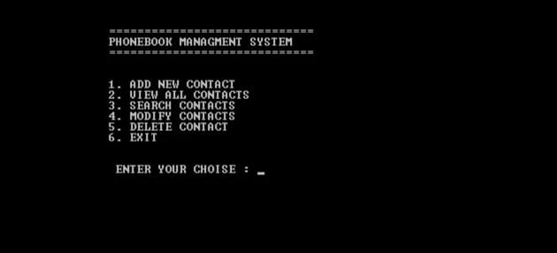

**ADD NEW CONTACT**

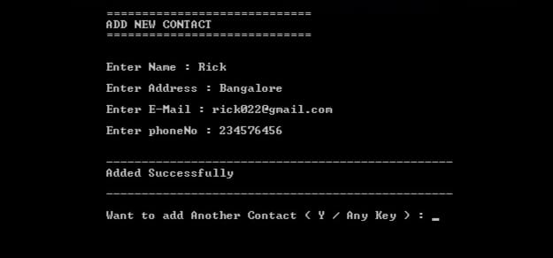

**VIEW ALL CONTACT**

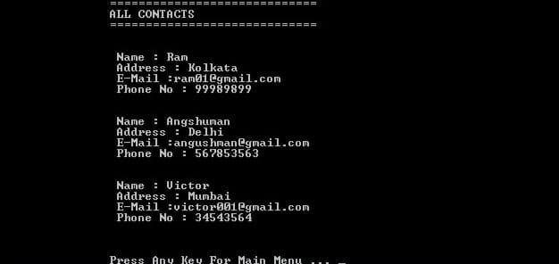

**SEARCH CONTACT**

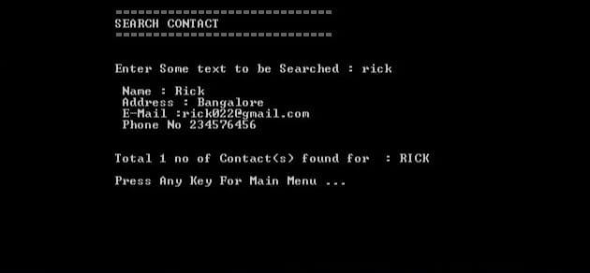

**UPDATE CONTACT DETAIL**

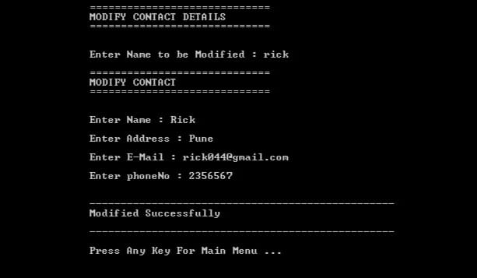

**DELETE CONTACT**

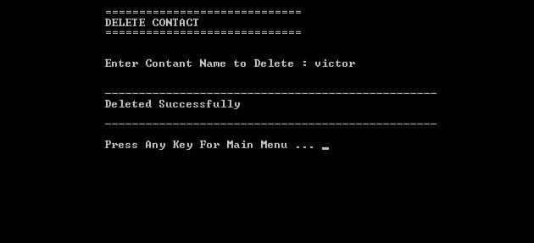

**CONCLUSION:**

The application program has been successfully implemented using experimental cases and the language used – C. C. This application works for other functions that make it easy to add new contact , view all contact , search contact , modify contacts and to delete contact.

**DECLARATION:**

I wanna thank me for believing in me.

**RERERENCES :**

GITHUB.COM